SYNOPSIS

This project is entitled "Gym Management System," which is a computerized management solution designed to streamline and automate the operations of a gym. The system is developed to manage various aspects of gym activities including member registration, workout sessions, billing, attendance tracking, and equipment management. It will help gym owners and managers efficiently manage member data, workout plans, schedules, payments, and more, in a user-friendly environment.
The Gym Management System provides features for the registration of new members, recording their personal and fitness details, and assigning appropriate workout programs based on their goals and fitness levels. The system also tracks attendance and provides real-time updates on the usage of gym equipment, ensuring optimal resource management. Billing and payment functionalities are automated, allowing for easy tracking of membership fees, subscriptions, and any additional services like personal training sessions or classes.
With this system, gym owners will be able to manage staff records, including trainers and administrative personnel, as well as track their performance and responsibilities. Reports related to membership growth, financial status, and staff performance will be generated automatically, offering valuable insights to support decision-making processes.
The proposed system will significantly improve the workflow of daily gym operations, reduce manual errors, and save time. By leveraging modern technology, the Gym Management System ensures that all data is securely stored and easily accessible, facilitating a seamless user experience for both gym staff and members.
The system is developed using PHP and MySQL. PHP, being a versatile and widely-used server-side scripting language, ensures efficient processing, while MySQL, an open-source relational database management system, guarantees fast and secure data storage and retrieval. The combination of these technologies offers a robust and scalable solution for managing gym operations.

INTRODUCTION

- INTRODUCTION

1.1 About the Project
The Gym Management System is designed to streamline and automate various administrative and operational tasks within a fitness center. This system facilitates member registration, attendance tracking, subscription management, trainer scheduling, and financial transactions. By implementing this system, gym owners and staff can efficiently manage their daily activities while improving member engagement and satisfaction.
With the increasing popularity of fitness and health consciousness, gyms require an effective management system to handle a growing number of members and services. This project aims to reduce manual work, minimize errors, and provide real-time insights into gym operations. The system ensures seamless communication between members, trainers, and management, ultimately enhancing the overall experience and efficiency of the gym.
Key features of the Gym Management System include:
- Member Registration & Profile Management – Enables easy enrollment and tracking of gym members.
- Subscription & Payment Management – Handles membership fees, due payments, and renewal notifications.
- Attendance Tracking – Monitors member and staff check-ins using RFID, biometric, or manual entry.
- Trainer & Schedule Management – Allows assigning trainers to members and managing workout schedules.
- Workout & Diet Plans – Provides personalized fitness plans based on member goals.
- Reports & Analytics – Generates reports on gym performance, revenue, and member activity.
The implementation of this system not only improves operational efficiency but also enhances the overall customer experience, making gym management more effective and hassle-free.
1.2 About the Language
The Gym Management System is developed using PHP as the backend language and MySQL as the database management system to ensure reliability, security, and scalability.
- Frontend: The user interface is built using HTML, CSS, and JavaScript, with additional support from Bootstrap for responsiveness.
- Backend: The core functionalities of the system are implemented using PHP, leveraging frameworks like Laravel or Core PHP for efficient server-side logic.
- Database: The system uses MySQL to store and manage member details, transactions, and schedules efficiently.
- Authentication & Security: Secure login and user authentication are implemented using PHP sessions and password hashing techniques (bcrypt) to ensure data privacy and protection against unauthorized access.
- Hosting & Deployment: The system can be deployed on Apache Server (XAMPP, LAMP, or WAMP) or hosted on cloud services like AWS, DigitalOcean, or cPanel-based shared hosting.
By leveraging PHP and MySQL, the Gym Management System ensures high performance, data security, and user-friendly access for both members and administrators. The combination of these technologies allows for efficient database management and a seamless user experience.

SYSTEM STUDY AND ANALYSIS
- SYSTEM STUDY AND ANALYSIS

2.1 Existing System
The current method of managing gym operations is largely manual, relying on paper records or basic spreadsheets to track memberships, attendance, and payments. This approach is time-consuming, prone to errors, and inefficient in handling a large volume of members.
2.2 Drawbacks of the Existing System
- Manual record-keeping leads to data loss and inconsistencies.
- Difficulty in tracking member subscriptions and payment status.
- Inefficient trainer scheduling and workout planning.
- Lack of automated attendance tracking.
- No centralized database for member and gym data.
2.3 System Analysis
A detailed analysis of the existing system highlights inefficiencies in managing memberships, tracking payments, and scheduling training sessions. The new system aims to automate these processes, reducing errors and improving operational efficiency.
2.4 Proposed System
- Automation reduces human errors and enhances efficiency.
- Secure and structured database management using MySQL.
- Improved member experience with personalized workout and diet plans.
- Real-time attendance and payment tracking.
- Simplified trainer and session management.
The proposed Gym Management System replaces manual operations with an automated solution that streamlines all aspects of gym management. It provides a centralized database, real-time updates, and a user-friendly interface for members and staff.

2.4.1 Advantages of the Proposed System
2.5 Feasibility Study
A feasibility study evaluates the practicality of implementing the proposed system.
2.5.1 Technical Feasibility
The system is developed using PHP and MySQL, ensuring easy deployment on widely available platforms like Apache.
2.5.2 Economic Feasibility
The cost of implementing the system is lower than maintaining a manual system, leading to cost savings in the long run.
2.5.3 Behavioral Feasibility
The system is designed to be user-friendly, reducing resistance to adoption by gym staff and members.
2.6 Hardware and Software Requirements
Hardware Requirements
- Server with at least 4GB RAM and 500GB storage.
- Workstations for staff with basic computing capabilities.
Software Requirements
- Operating System: Windows/Linux/MacOS.
- Web Server: Apache with PHP support.
- Database: MySQL.
- Browser: Chrome, Firefox, or Edge for system access.
The proposed system ensures a more efficient and reliable way of managing gym operations, ultimately enhancing user experience and operational effectiveness.

SYSTEM DESIGN AND DEVELOPMENT PROCESS

3. SYSTEM DESIGN AND DEVELOPMENT PROCESS

3.1 Introduction
System design involves the planning and structuring of the Gym Management System to ensure efficiency, reliability, and ease of use. This phase focuses on defining system architecture, data flow, and interface design to meet user requirements.
3.2 Input Design
The input design focuses on capturing user data efficiently while ensuring data accuracy and security. Key input forms include:
- Member Registration Form – Captures personal details, membership type, and payment details.
- Trainer Scheduling Form – Allows assigning trainers to specific members and sessions.
- Attendance Tracking – Enables members to check in via biometric, RFID, or manual entry.
- Payment and Subscription Forms – Tracks membership payments, due amounts, and renewal dates.
3.3 Output Design
The output design ensures that processed data is presented in an intuitive and meaningful way. Key outputs include:
- Membership Reports – Displays active, expired, and pending memberships.
- Trainer Schedules – Provides a detailed schedule of trainers and assigned sessions.
- Attendance Reports – Tracks daily, weekly, and monthly attendance.
- Payment Reports – Shows financial transactions and outstanding dues.
3.4 Database Design
The database design ensures efficient storage and retrieval of gym-related data. The system uses MySQL as the database management system, with the following key tables:
- Users Table – Stores member and admin login credentials.
- Members Table – Stores member personal details and subscription history.
- Trainers Table – Contains trainer details, assigned members, and schedules.
- Attendance Table – Tracks member and staff check-in/check-out times.
- Payments Table – Manages membership fees, payment status, and due dates.
A well-structured database ensures data integrity, reduces redundancy, and improves system performance. The Gym Management System is designed to provide seamless data access and management for an enhanced user experience.
3.5. Table Design
Table: user
Primary Key: userid
Field | Data Type | Constraints | Description
userid | Varchar | Primary key | User ID
username | Varchar |  | User Name
gender | Varchar |  | Gender
mobile | Varchar |  | Mobile
email | Varchar |  | Email
dob | Varchar |  | Date Of Birth
joining_date | Varchar |  | Joining Date

Table: admin
Primary Key: id
Field | Data Type | Constraints | Description
id | int | Primary key | ID
username | Varchar |  | User Name
pass_key | Varchar |  | Password
securekey | Varchar |  | Secure Key
Full_name | Varchar |  | Full Name

Table: address
Primary Key: id
Field | Data Type | Constraints | Description
id | Varchar | Primary key | ID
streetName | Varchar |  | Street Name
state | Varchar |  | State
city | Varchar |  | City
zipcode | Varchar |  | Zipcode

Table: enrolls_to
Primary Key: uid
Field | Data Type | Constraints | Description
uid | Varchar |  | User ID
et_id | Int | Primary key | Enroll ID
pid | Varchar |  | Paid ID
paid_date | Varchar |  | Paid Date
expire | Varchar |  | Expire Date
renewal | Varchar |  | Renewal

Table: health_status
Primary Key: hid
Field | Data Type | Constraints | Description
hid | int | Primary key | Health ID
calorie | Varchar |  | Calorie
height | Varchar |  | Height
weight | Varchar |  | Weight
fat | Varchar |  | Fat
remarks | Varchar |  | Remark
uid | Varchar |  | User ID

Table: plan
Primary Key: pid

Field | Data Type | Constraints | Description
pid | Varchar | Primary key | Plan ID
planName | Varchar |  | Plan Name
description | Varchar |  | Description
validity | Varchar |  | Validity
amount | Int |  | Amount
active | Varchar |  | Active

Table: timetable
Primary Key: tid
Field | Data Type | Constraints | Description
tid | Int | Primary key | Table ID
tname | Varchar |  | Table Name
day1 | Varchar |  | Day 1
day2 | Varchar |  | Day 2
day3 | Varchar |  | Day 3
day4 | Varchar |  | Day 4
day5 | Varchar |  | Day 5
day6 | Varchar |  | Day 6

3.6. Data Flow Diagram:
Level 1 :
SCULPT GYM
Admin
Level 2 :
New Plan
View Member

Exercise Routine
Add Routine
Logout
Edit Routine
Profile
Members per Year
Members per Month
Edit Subscription Details
Payments
Dashboard
New Registration
View Routine
Income per Month
Overview
Admin
Health Status
Plan
Members
Edit Members
3.7 ER Diagram:
User
userid
username
gender

email
mobile
joining_date
dob

user

Admin

id
pass_key
username

Full_name
securekey

admin

Address
id
streetName
state

zipcode
city

address

Enrolls To

et_id
uid
pid
expire

renewal
paid_date
enrolls_to

Health Status

hid
calorie
height

fat
weight

uid
remarks
health_status

Plan
description
pid
planName
amount
validity
active
plan

Time Table
id

day1
tname

timetable
day2
day3

day4
day5
day6

SYSTEM TESTING AND IMPLEMENTATION

4. SYSTEM TESTING AND IMPLEMENTATION
4.1. System Testing
4.1.1. Unit Testing
- Unit testing involves testing individual components of the system, such as:
    - Member Registration Module: Checking if users can successfully register and their details are stored correctly.
    - Payment Processing Module: Ensuring that transactions are correctly processed.
  - Workout Scheduling Module: Verifying if trainers can create, edit, and assign workout plans.
- Performed by developers using automated tools like JUnit or manual test cases.
4.1.2. Integration Testing
- Focuses on verifying interactions between different modules, such as:
  - Member Module & Payment Module: Ensuring that when a member makes a payment, their membership status updates correctly.
  - Trainer Module & Schedule Module: Checking if trainers can assign schedules to members and if they reflect in the user’s profile.
  - Equipment Tracking & Maintenance Module: Ensuring that gym staff can log maintenance requests and receive notifications.
- Uses tools like Selenium for web-based applications.
4.1.3. Validation Testing
- Ensures the system meets business requirements.
- Key validation areas include:
  - User Authentication: Validating login, role-based access, and security features.
  - Reports & Analytics: Checking if the system generates accurate reports on attendance, revenue, and member progress.
  - Mobile Compatibility: Ensuring the system works well on mobile devices for trainers and members.
4.1.4. Output Testing or User Acceptance Testing (UAT)
- Conducted with actual gym staff, trainers, and members.
- Ensures that:
  - Members can register, book workouts, make payments, and receive reminders.
  - Trainers can schedule sessions, track progress, and update workout plans.
  - Gym admins can manage subscriptions, generate reports, and handle maintenance requests.
- Any feedback from end-users is used to improve the system before deployment.
4.2. System Implementation
- The gym management system is deployed in phases:
  - Pilot Deployment: Implementing the system in one gym branch before a full rollout.
  - Parallel Deployment: Running the new system alongside the existing manual system to compare results.
  - Full Deployment: Replacing the old system entirely once testing and training are successful.
- Data migration from old systems (spreadsheets/manual records) to the new system is completed.
4.3. Training
- Training ensures that gym staff, trainers, and members can effectively use the system.
- Types of training:
  - Admin Training: Focuses on membership management, payment processing, and report generation.
  - Trainer Training: Covers schedule creation, member progress tracking, and workout planning.
  - Member Training: Helps users navigate the app/portal, book sessions, and make payments.
- Training methods:
  - On-site Training: Hands-on training sessions at the gym.
  - Online Tutorials: Video guides and FAQs for members.
  - Help Desk Support: Dedicated support team for troubleshooting.
4.4. System Maintenance
- Corrective Maintenance: Fixes bugs or errors encountered after deployment.
- Preventive Maintenance: Regular updates to enhance performance and security.
- Adaptive Maintenance: Modifications to accommodate new features (e.g., integration with wearable fitness devices).
- User Support: Providing continuous support through chatbots, FAQs, or customer service.

APPENDIX

5. APPENDIX

5.1. Sample Source Code
Index.php
<?php
require '../../include/db_conn.php';
page_protect();
?>
<!DOCTYPE html>
<html lang="en">
<head>
<title>Gym | Dashboard </title>
<link rel="stylesheet" href="../../css/style.css" id="style-resource-5">
<script type="text/javascript" src="../../js/Script.js"></script>
<link rel="stylesheet" href="../../css/dashMain.css">
<link rel="stylesheet" type="text/css" href="../../css/entypo.css">
<style>
.page-container .sidebar-menu #main-menu li#dash > a {
background-color: #2b303a;
color: #ffffff;
}
</style>
</head>
<body class="page-body page-fade" onload="collapseSidebar()">
<div class="page-container sidebar-collapsed" id="navbarcollapse">
<div class="sidebar-menu">
<header class="logo-env">
<!-- logo -->
<!-- logo collapse icon -->
<div class="sidebar-collapse" onclick="collapseSidebar()">
<a href="#" class="sidebar-collapse-icon with-animation"><!-- add class "with-animation" if you want sidebar to have animation during expanding/collapsing transition -->
<i class="entypo-menu"></i>
</a>
</div>
</header>
<?php include('nav.php'); ?>
</div>
<div class="main-content">
<div class="row">
<!-- Profile Info and Notifications -->
<div class="col-md-6 col-sm-8 clearfix">
</div>
<!-- Raw Links -->
<div class="col-md-6 col-sm-4 clearfix hidden-xs">
<ul class="list-inline links-list pull-right">
<li>Welcome <?php echo $_SESSION['full_name']; ?>
</li>
<li>
<a href="logout.php">
Log Out <i class="entypo-logout right"></i>
</a>
</li>
</ul>
</div>
</div>
<h2>Gym Dashboard</h2>
<hr>
<div class="col-sm-3"><a href="revenue_month.php">
<div class="tile-stats tile-red">
<div class="num" data-postfix="" data-duration="1500" data-delay="0">
<h2>Total Gym Income</h2>
<?php
date_default_timezone_set("Asia/Calcutta");
$date = date('Y-m');
$query = "select * from enrolls_to WHERE paid_date LIKE '$date%'
//echo $query;
$result = mysqli_query($con, $query);
$revenue = 0;
if (mysqli_affected_rows($con) != 0) {
while ($row = mysqli_fetch_array($result, MYSQLI_ASSOC)) {
$query1="select * from plan where pid='".$row['pid']."'";
$result1=mysqli_query($con,$query1);
if($result1){
$value=mysqli_fetch_row($result1);
$revenue = $value[4] + $revenue;
}
}
}
echo "".$revenue;
?>
</div>
</div></a>
</div>
<div class="col-sm-3"><a href="table_view.php">
<div class="tile-stats tile-green">
<div class="num" data-postfix="" data-duration="1500" data-delay="0">
<h2>Total Members</h2>
<?php
$query = "select COUNT(*) from users";
$result = mysqli_query($con, $query);
$i = 1;
if (mysqli_affected_rows($con) != 0) {
while ($row = mysqli_fetch_array($result, MYSQLI_ASSOC)) {
echo $row['COUNT(*)'];
}
}
$i = 1;
?>
</div>
</div></a>
</div>
<div class="col-sm-3"><a href="over_members_month.php">
<div class="tile-stats tile-aqua">

<div class="num" data-postfix="" data-duration="1500" data-delay="0">
<h2>New Members</h2>
<?php
date_default_timezone_set("Asia/Calcutta");
$date = date('Y-m');
$query = "select COUNT(*) from users WHERE joining_date LIKE '$date%'";
//echo $query;
$result = mysqli_query($con, $query);
$i = 1;
if (mysqli_affected_rows($con) != 0) {
while ($row = mysqli_fetch_array($result, MYSQLI_ASSOC)) {
echo $row['COUNT(*)'];
}
}
$i = 1;
?>
</div>
</div></a>
</div>
<div class="col-sm-3"><a href="view_plan.php">
<div class="tile-stats tile-blue">
<div class="num" data-postfix="" data-duration="1500" data-delay="0">
<h2>Available Plans</h2>
<?php
$query = "select COUNT(*) from plan where active='yes'";
//echo $query;
$result = mysqli_query($con, $query);
$i = 1;
if (mysqli_affected_rows($con) != 0) {
while ($row = mysqli_fetch_array($result, MYSQLI_ASSOC)) {
echo $row['COUNT(*)'];
}
}
$i = 1;
?>
</div>
</div></a>
</div>
<?php include('footer.php'); ?>
</div>
</body>
</html>

Table_view.php
<?php
require '../../include/db_conn.php';
page_protect();
?>
<!DOCTYPE html>
<html lang="en">
<head>
<title>Gym | View Member</title>
<link rel="stylesheet" href="../../css/style.css" id="style-resource-5">
<script type="text/javascript" src="../../js/Script.js"></script>
<link rel="stylesheet" href="../../css/dashMain.css">
<link rel="stylesheet" type="text/css" href="../../css/entypo.css">
<link href="a1style.css" rel="stylesheet" type="text/css">
<link rel="stylesheet" href="https://stackpath.bootstrapcdn.com/bootstrap/4.3.1/css/bootstrap.min.css" integrity="sha384-ggOyR0iXCbMQv3Xipma34MD+dH/1fQ784/j6cY/iJTQUOhcWr7x9JvoRxT2MZw1T" crossorigin="anonymous">
<style>
#button1
{
width:126px;
}
.page-container .sidebar-menu #main-menu li#hassubopen > a {
background-color: #2b303a;
color: #ffffff;
}
#button2{
width:126px;
background-color:rgb(243, 44, 17);
border : unset;
border-radius : unset;
}
#button2:hover{
width:126px;
background-color:rgba(241, 68, 45, 0.83)!important;
border : unset;
border-radius : unset;
}
</style>
</head>
<body class="page-body page-fade" onload="collapseSidebar()">
<div class="page-container sidebar-collapsed" id="navbarcollapse">
<div class="sidebar-menu">
<header class="logo-env">
<!-- logo collapse icon -->
<div class="sidebar-collapse" onclick="collapseSidebar()">
<a href="#" class="sidebar-collapse-icon with-animation"><!-- add class "with-animation" if you want sidebar to have animation during expanding/collapsing transition -->
<i class="entypo-menu"></i>
</a>
</div>
</header>
<?php include('nav.php'); ?>
</div>
<div class="main-content">
<div class="row">
<!-- Profile Info and Notifications -->
<div class="col-md-6 col-sm-8 clearfix">
</div>
<!-- Raw Links -->
<div class="col-md-6 col-sm-4 clearfix hidden-xs">
<ul class="list-inline links-list pull-right">
<li>Welcome <?php echo $_SESSION['full_name']; ?>
</li>
<li>
<a href="logout.php">
Log Out <i class="entypo-logout right"></i>
</a>
</li>
</ul>
</div>
</div>
<h3>Member Detail</h3>
<hr />
<!-- Exprie table -->
<h4 style="color:rgb(243, 223, 38)">Exprie Member</h4>
<table class="table table-bordered datatable" id="table-1" border=1>
<thead>
<tr><h2>
<th>Sl.No</th>
<th>Membership Expiry</th>
<th>Member ID</th>
<th>Name</th>
<th>Contact</th>
<th>E-Mail</th>
<th>Gender</th>
<th>Joining Date</th>
<th>Action</th></h2>
</tr>
</thead>
<tbody>
<?php
$query = "select * from users ORDER BY joining_date";
//echo $query;
$result = mysqli_query($con, $query);
$sno = 1;
if (mysqli_affected_rows($con) != 0) {
while ($row = mysqli_fetch_array($result, MYSQLI_ASSOC)) {
$uid = $row['userid'];
$query1 = "SELECT * FROM enrolls_to WHERE renewal='yes'and uid='$uid' ";
$result1 = mysqli_query($con, $query1);
if (mysqli_affected_rows($con) == 1) {
while ($row1 = mysqli_fetch_array($result1, MYSQLI_ASSOC)) {
$currentDate = date("Y-m-d");
$expireDate = $row1['expire'];
$threeDaysBeforeExpireDate = date("Y-m-d", strtotime($expireDate . " -3 days"));
if ($threeDaysBeforeExpireDate <= $expireDate) {
$style = "color: red;";
} else {
$style = "";
}
$expdate=date("d-m-Y",strtotime($expireDate));
echo "<tr><td>".$sno."</td>";
echo "<td style='$style'>" . $expdate . "</td>";
echo "<td>" . $row['userid'] . "</td>";
echo "<td>" . $row['username'] . "</td>";
echo "<td>" . $row['mobile'] . "</td>";
echo "<td>" . $row['email'] . "</td>";
echo "<td>" . $row['gender'] . "</td>";
echo "<td>" . $row['joining_date'] ."</td>";
$sno++;
echo "<td>
<div>
<form action='viewall_detail.php' method='post'>
<input type='hidden' name='name' value='" . $uid . "'/>
<input type='submit' class='a1-btn a1-blue' id='button1' value='View All ' class='btn btn-info'/>
</form>
</div>
<div>
<form action='send-mail.php' method='post'>
<input type='hidden' name='name' value='" . $uid . "'/>
<input type='hidden' name='mail' value='" . $row['email'] . "'/>
<input type='submit' id='button2' value='Reminder ' class='btn btn-info'/>
</form>
</div>
</td>
</tr>";
$msgid = 0;
}
}
}
}
?>
</tbody>
</table>
<!-- Current table -->
<h4 style="color:rgb(243, 223, 38)">Current Member</h4>
<table class="table table-bordered datatable" id="table-1" border=1>
<thead>
<tr><h2>
<th>Sl.No</th>
<th>Membership Expiry</th>
<th>Member ID</th>
<th>Name</th>
<th>Contact</th>
<th>E-Mail</th>
<th>Gender</th>
<th>Joining Date</th>
<th>Action</th></h2>
</tr>
</thead>
<tbody>
<?php
$query = "select * from users ORDER BY joining_date";
//echo $query;
$result = mysqli_query($con, $query);
$sno = 1;
if (mysqli_affected_rows($con) != 0) {
while ($row = mysqli_fetch_array($result, MYSQLI_ASSOC)) {
$uid = $row['userid'];
$query1 = "SELECT * FROM enrolls_to WHERE uid='$uid' and renewal='no'";
$result1 = mysqli_query($con, $query1);
if (mysqli_affected_rows($con) == 1) {
while ($row1 = mysqli_fetch_array($result1, MYSQLI_ASSOC)) {
$currentDate = date("Y-m-d");
$expireDate = $row1['expire'];
$threeDaysBeforeExpireDate = date("Y-m-d", strtotime($expireDate . " -3 d
$expdate=date("d-m-Y",strtotime($expireDate));
echo "<tr><td>".$sno."</td>";
echo "<td>" . $expdate . "</td>";
echo "<td>" . $row['userid'] . "</td>";
echo "<td>" . $row['username'] . "</td>";
echo "<td>" . $row['mobile'] . "</td>";
echo "<td>" . $row['email'] . "</td>";
echo "<td>" . $row['gender'] . "</td>";
echo "<td>" . $row['joining_date'] ."</td>";
$sno++;
echo "<td><form action='viewall_detail.php' method='post'><input type='hidden' name='name' value='" . $uid . "'/><input type='submit' class='a1-btn a1-blue' id='button1' value='View All ' class='btn btn-info'/></form></td></tr>";
$msgid = 0;
}
}
}
}
?>
</tbody>
</table>
<script>
function ConfirmDelete(name){
var r = confirm("Are you sure! You want to Delete this User?");
if (r == true) {
return true;
} else {
return false;
}
}
</script>
<?php include('footer.php'); ?>
</div>
</body>
</html>
View_plan.php
<?php
require '../../include/db_conn.php';
page_protect();
?>
<!DOCTYPE html>
<html lang="en">
<head>
<title>Gym| View Plan</title>
<link rel="stylesheet" href="../../css/style.css" id="style-resource-5">
<script type="text/javascript" src="../../js/Script.js"></script>
<link rel="stylesheet" href="../../css/dashMain.css">
<link rel="stylesheet" type="text/css" href="../../css/entypo.css">
<link href="a1style.css" rel="stylesheet" type="text/css">
<link rel="stylesheet" href="https://stackpath.bootstrapcdn.com/bootstrap/4.3.1/css/bootstrap.min.css" integrity="sha384-ggOyR0iXCbMQv3Xipma34MD+dH/1fQ784/j6cY/iJTQUOhcWr7x9JvoRxT2MZw1T" crossorigin="anonymous">
<style>
#button1
{
width:126px;
}
.page-container .sidebar-menu #main-menu li#planhassubopen > a {
background-color: #2b303a;
color: #ffffff;
}
</style>
</head>
<body class="page-body page-fade" onload="collapseSidebar()">
<div class="page-container sidebar-collapsed" id="navbarcollapse">
<div class="sidebar-menu">
<header class="logo-env">
<!-- logo collapse icon -->
<div class="sidebar-collapse" onclick="collapseSidebar()">
<a href="#" class="sidebar-collapse-icon with-animation"><!-- add class "with-animation" if you want sidebar to have animation during expanding/collapsing transition -->
<i class="entypo-menu"></i>
</a>
</div>
</header>
<?php include('nav.php'); ?>
</div>
<div class="main-content">
<div class="row">
<!-- Profile Info and Notifications -->
<div class="col-md-6 col-sm-8 clearfix">
</div>
<!-- Raw Links -->
<div class="col-md-6 col-sm-4 clearfix hidden-xs">
<ul class="list-inline links-list pull-right">
<li>Welcome <?php echo $_SESSION['full_name']; ?>
</li>
<li>
<a href="logout.php">
Log Out <i class="entypo-logout right"></i>
</a>
</li>
</ul>
</div>
</div>
<h3>Manage Plan</h3>
<hr />
<table class="table table-bordered datatable" id="table-1" border=1>
<thead>
<tr>
<th>S.No</th>
<th>Plan ID</th>
<th>Plan name</th>
<th>Plan Details</th>
<th>Months</th>
<th>Rate</th>
<th>Action</th>
</tr>
</thead>
<tbody>
<?php
$query = "select * from plan where active='yes' ORDER BY amount DESC";
//echo $query;
$result = mysqli_query($con, $query);
$sno = 1;
if (mysqli_affected_rows($con) != 0) {
while ($row = mysqli_fetch_array($result, MYSQLI_ASSOC)) {
$msgid = $row['pid'];
echo "<tr><td>" . $sno . "</td>";
echo "<td>" . $row['pid'] . "</td>";
echo "<td>" . $row['planName'] . "</td>";
echo "<td width='380'>" . $row['description'] . "</td>";
echo "<td>" . $row['validity'] . "</td>";
echo "<td>" . $row['amount'] . "</td>";
$sno++;
echo '<td><a href=edit_plan.php?id="'.$row['pid'].'"><input type="button" class="a1-btn a1-blue" id="boxxe" style="width:100%" value="Edit Plan" ></a><form action="del_plan.php" method="post" onSubmit="return ConfirmDelete();"><input type="hidden" name="name" value="' . $msgid .'"/><input type="submit" id="button1" value="Delete Plan" class="a1-btn a1-orange"/></form></td></tr>';
$msgid = 0;
}
}
?>
</tbody>
</table>
<?php include('footer.php'); ?>
</div>
</body>
</html>
Viewdetailroutine.php
<?php
require '../../include/db_conn.php';
page_protect();
?>
<!DOCTYPE html>
<html lang="en">
<head>
<title>Gym | Detail Routine</title>
<link rel="stylesheet" href="../../css/style.css" id="style-resource-5">
<script type="text/javascript" src="../../js/Script.js"></script>
<link rel="stylesheet" href="../../css/dashMain.css">
<link rel="stylesheet" type="text/css" href="../../css/entypo.css">
<link href="a1style.css" rel="stylesheet" type="text/css">
<link rel="stylesheet" href="https://stackpath.bootstrapcdn.com/bootstrap/4.3.1/css/bootstrap.min.css" integrity="sha384-ggOyR0iXCbMQv3Xipma34MD+dH/1fQ784/j6cY/iJTQUOhcWr7x9JvoRxT2MZw1T" crossorigin="anonymous">
<style>
.page-container .sidebar-menu #main-menu li#routinehassubopen > a {
background-color: #2b303a;
color: #ffffff;
}
</style>
<script>
function myFunction()
{
var prt=document.getElementById("print");
var WinPrint=window.open('','','left=0,top=0,width=800,height=900,tollbar=0,scrollbars=0,status=0');
WinPrint.document.write(prt.innerHTML);
WinPrint.document.close();
WinPrint.focus();
WinPrint.print();
WinPrint.close();
setPageHeight("297mm");
setPageWidth("210mm");
setHtmlZoom(100);
//window.location.replace("index.php?query=");
}
</script>
</head>
<body class="page-body page-fade" onload="collapseSidebar()">
<div class="page-container sidebar-collapsed" id="navbarcollapse">
<div class="sidebar-menu">
<header class="logo-env">
<!-- logo collapse icon -->
<div class="sidebar-collapse" onclick="collapseSidebar()">
<a href="#" class="sidebar-collapse-icon with-animation"><!-- add class "with-animation" if you want sidebar to have animation during expanding/collapsing transition -->
<i class="entypo-menu"></i>
</a>
</div>
</header>
<?php include('nav.php'); ?>
</div>
<div class="main-content">
<div class="row">
<!-- Profile Info and Notifications -->
<div class="col-md-6 col-sm-8 clearfix">
</div>
<!-- Raw Links -->
<div class="col-md-6 col-sm-4 clearfix hidden-xs">
<ul class="list-inline links-list pull-right">
<li>Welcome <?php echo $_SESSION['full_name']; ?>
</li>
<li>
<a href="logout.php">
Log Out <i class="entypo-logout right"></i>
</a>
</li>
</ul>
</div>
</div>
<h2>Routine Detail</h2>
<hr/>
<?php
$id=$_GET['id'];
$sql="Select * from timetable t Where t.tid=$id";
$res=mysqli_query($con, $sql);
if($res){
$row=mysqli_fetch_array($res,MYSQLI_ASSOC);
}
?>
<div id=print>
<table width="619" height="673" border="1" align="center">
<tr>
<td height="87" colspan="2">Routine Name:<?php echo $row['tname'] ?> &ensp;&ensp;&ensp;&ensp;&ensp; &ensp;&ensp;&ensp;&ensp;&ensp; &ensp;&ensp;&ensp;&ensp;&ensp; &ensp;&ensp;&ensp;&ensp;&ensp; &ensp;&ensp;&ensp;&ensp;&ensp;&ensp;&ensp;&ensp;&ensp;&ensp; &ensp;&ensp;&ensp;&ensp;&ensp;<span align="right"></span></td>
</tr>
<tr>
<td width="186" height="103">Day 1:</td>
<td width="417"><?php echo $row['day1'] ?></td>
</tr>
<tr>
<td height="96">Day 2:</td>
<td><?php echo $row['day2'] ?></td>
</tr>
<tr>
<td height="87">Day 3:</td>
<td><?php echo $row['day3'] ?></td>
</tr>
<tr>
<td height="92">Day 4:</td>
<td><?php echo $row['day4'] ?></td>
</tr>
<tr>
<td height="84">Day 5:</td>
<td><?php echo $row['day5'] ?></td>
</tr>
<tr>
<td height="75">Day 6:</td>
<td><?php echo $row['day6'] ?></td>
</tr>
</table></div>
<input type="button" class="a1-btn a1-blue" value="PRINT ROUTINE" onclick="myFunction()">
</div>
</body>
<?php include('footer.php'); ?>
</html>
5.2. Screen Shots

Login page:
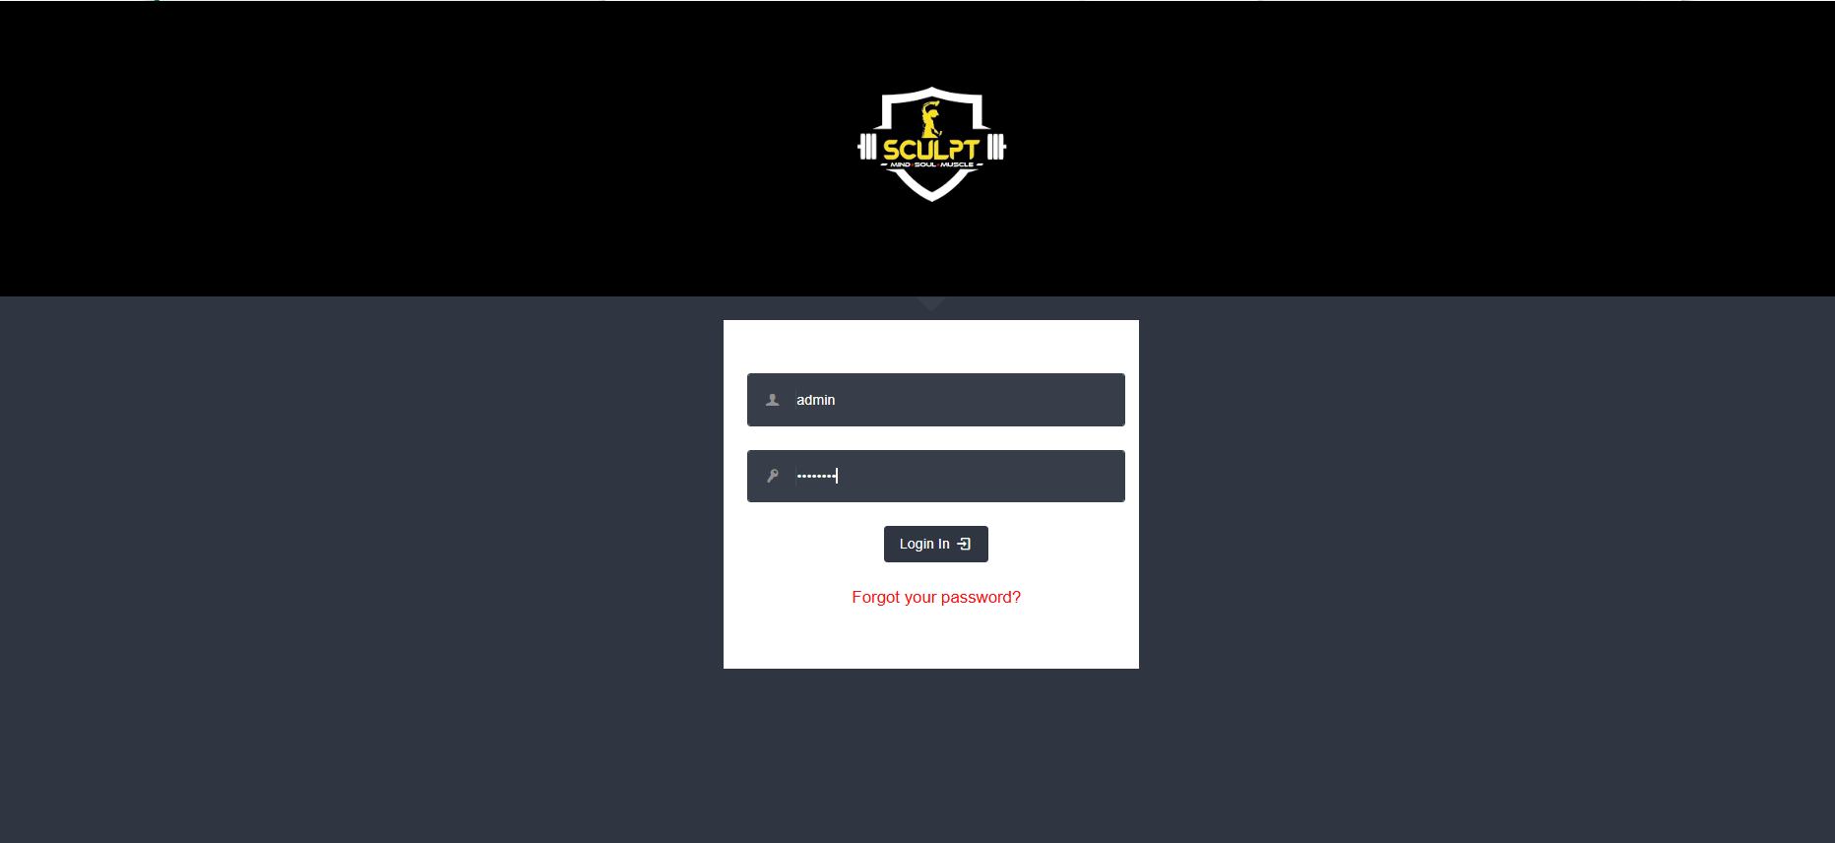

The image shows a gym management system login page for SCULPT - Mind Soul Muscle with a dark-themed design. It features a login form with fields for username, password, a login button, and a password recovery option. The SCULPT logo is displayed at the top, emphasizing the brand identity.

Dashboard :

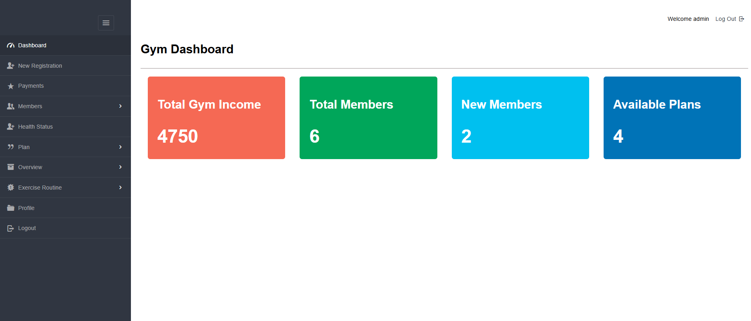

The image displays a gym dashboard with key statistics. It shows the total gym income, providing an overview of earnings. The total number of members is also displayed for tracking growth. Newly registered members are highlighted separately. Available membership plans are listed for easy selection. The dashboard helps in monitoring financial and membership details. This ensures efficient management of the gym’s operations.

Registration Page :

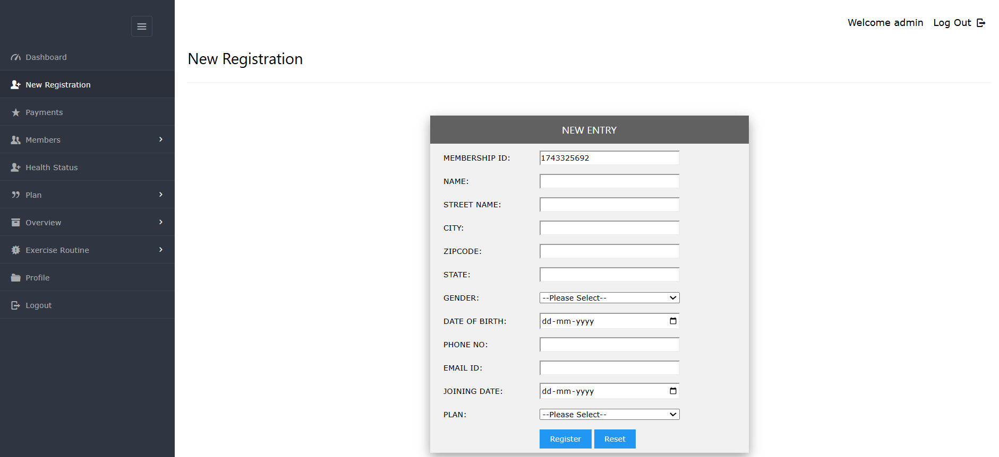

The image displays a new registration page for a client. They are required to enter their full details for the signup process. The form collects essential information for membership. Once all details are filled in, the client can proceed. The system verifies the entered information for accuracy. After successful submission, the registration is completed. This ensures a smooth and efficient onboarding process.

Payment Page :

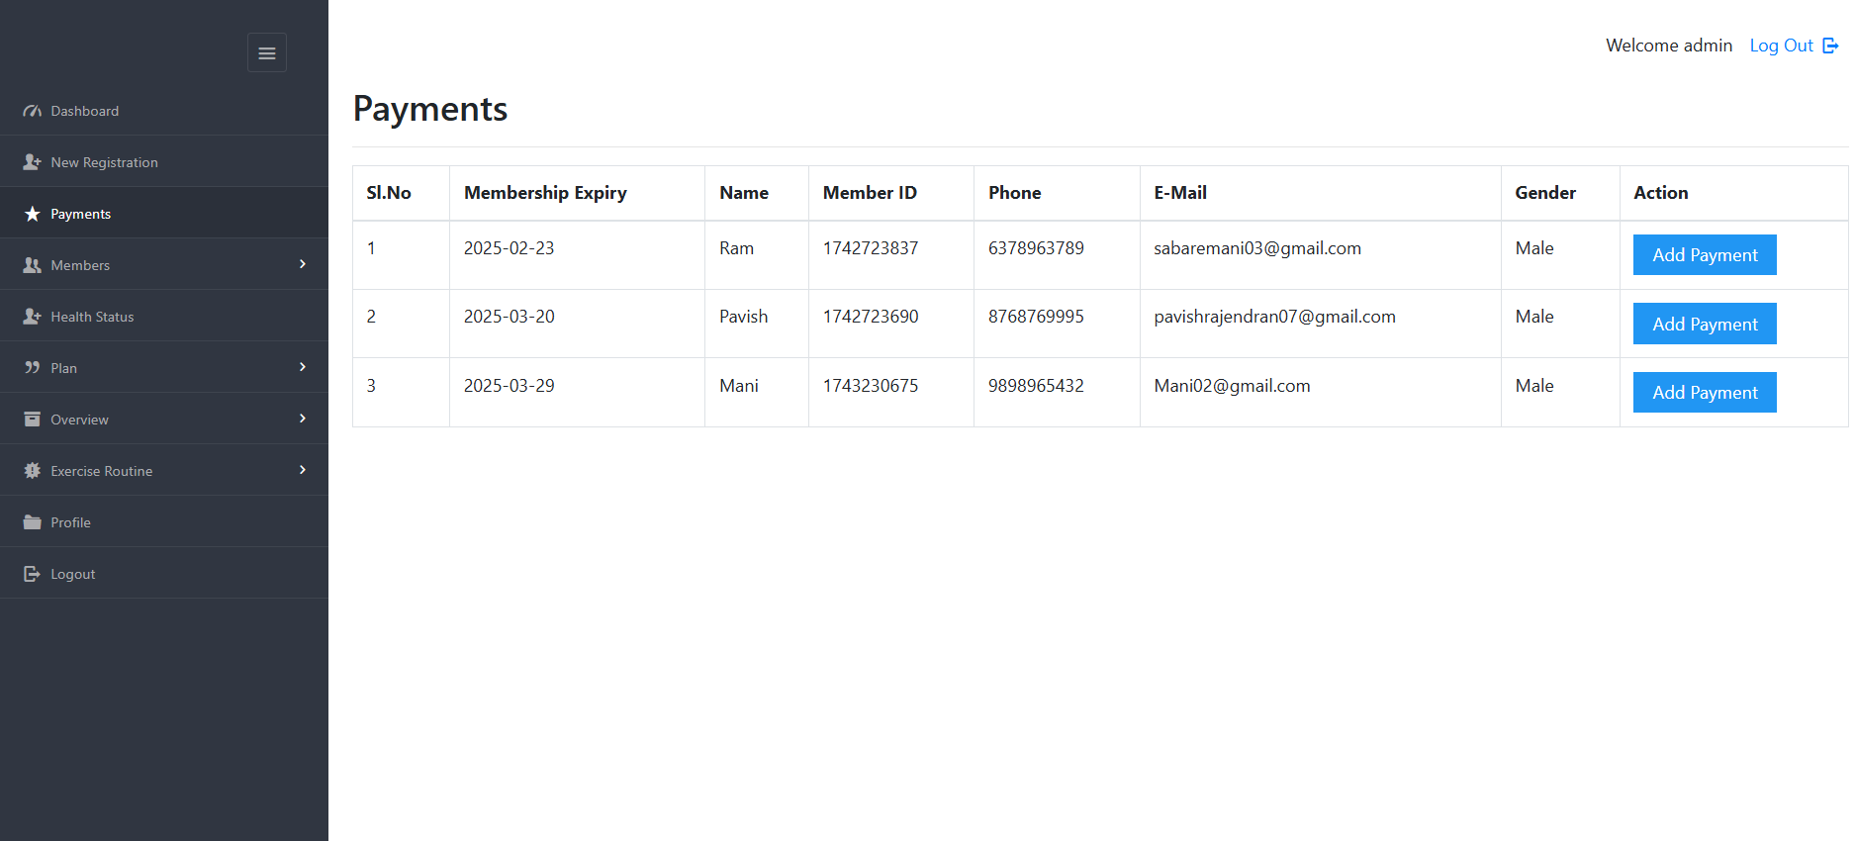

The image displays a payment page for the client. They will make a payment based on the selected plan. A payment button is provided for proceeding with the transaction. When the client clicks the button, they are redirected to the payment page. The system processes the payment details securely. Upon successful completion, a confirmation message appears. This ensures a smooth and hassle-free payment experience.

Make Payment Page:

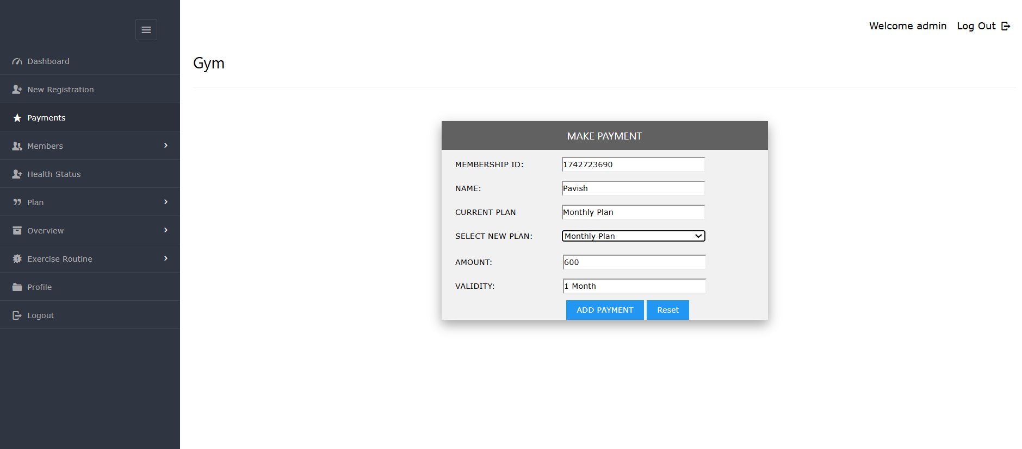

The image displays a "Make Payment" page for the client. They can choose a plan and proceed with the payment. An "Add Payment" button is available for confirmation. Once the button is clicked, the transaction is processed. The system verifies the payment details. Upon successful completion, a confirmation message appears. This ensures a smooth and secure payment process.

Members :
Member Details Page :

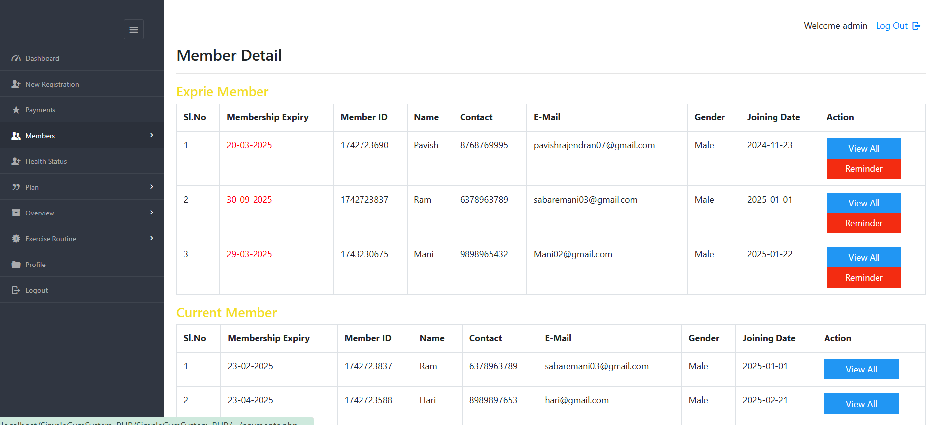

The image displays member details along with two tables. One table shows expired memberships for easy tracking. The other table lists current members with active packages. This helps in managing membership renewals efficiently. The expired table highlights members who need to renew their plans. The active package table ensures smooth monitoring of ongoing memberships. This setup allows for effective membership management and organization.

Edit Member Page :

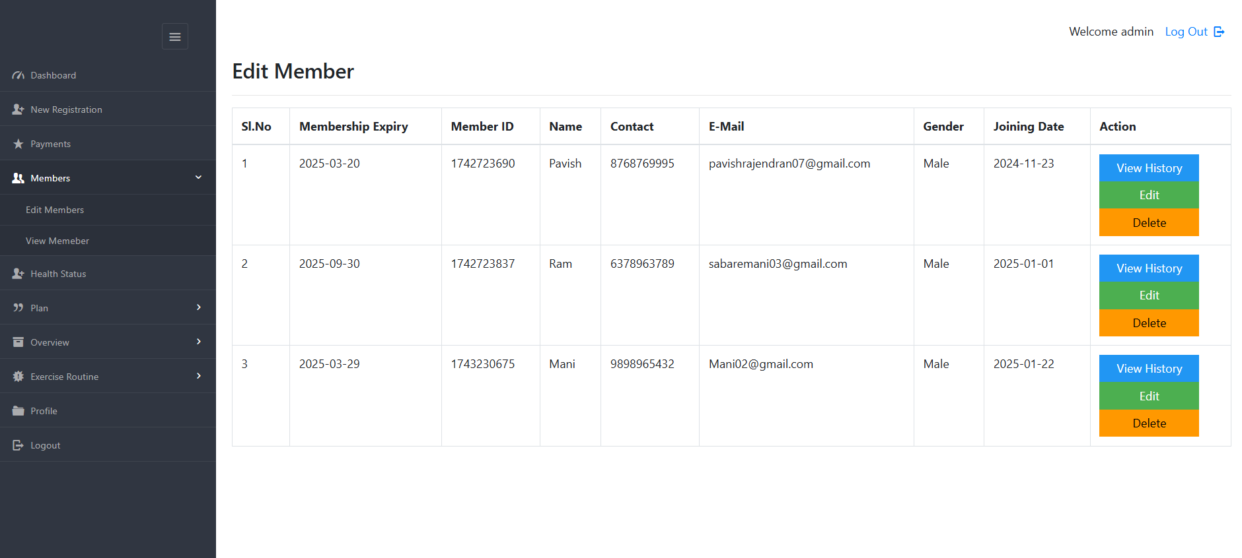

The image displays an "Edit Member" section. It includes three action buttons for managing member details. The "View Details" button allows checking member information. The "Edit" button enables modifications to the member’s data. The "Delete" button removes a member from the system if needed. These options help in efficiently managing gym memberships. This setup ensures smooth updates and record maintenance.

Health Satus Pages:

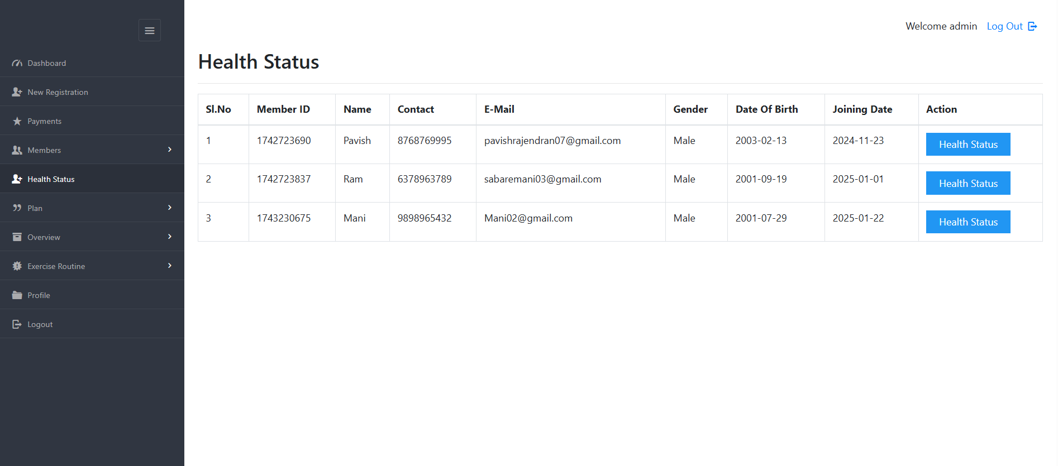

The image displays a "Health Status" section. It provides essential health-related details of the member. A single button labeled "Health Status" is available for interaction. Clicking the button may show detailed health records. This feature helps in tracking the member’s fitness progress. It ensures easy access to health information when needed. The setup supports better health monitoring and management.

Edit Health Page :

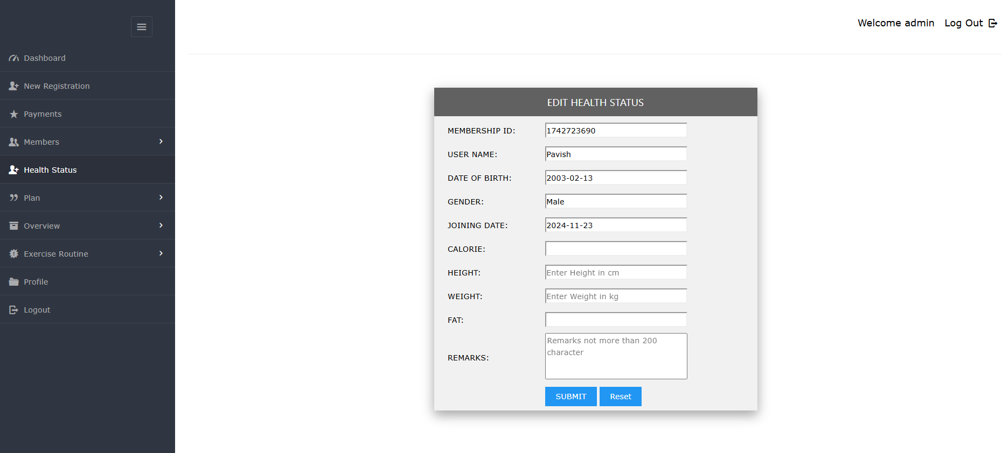

The image displays an "Edit Health Status" section. It allows updating a member’s health information. Users can modify health details as needed. This feature ensures accurate and up-to-date health records. Keeping records updated helps in tracking fitness progress. It supports better health management and monitoring. The setup ensures easy and efficient health status updates.

Plan :
Create Plan Page :

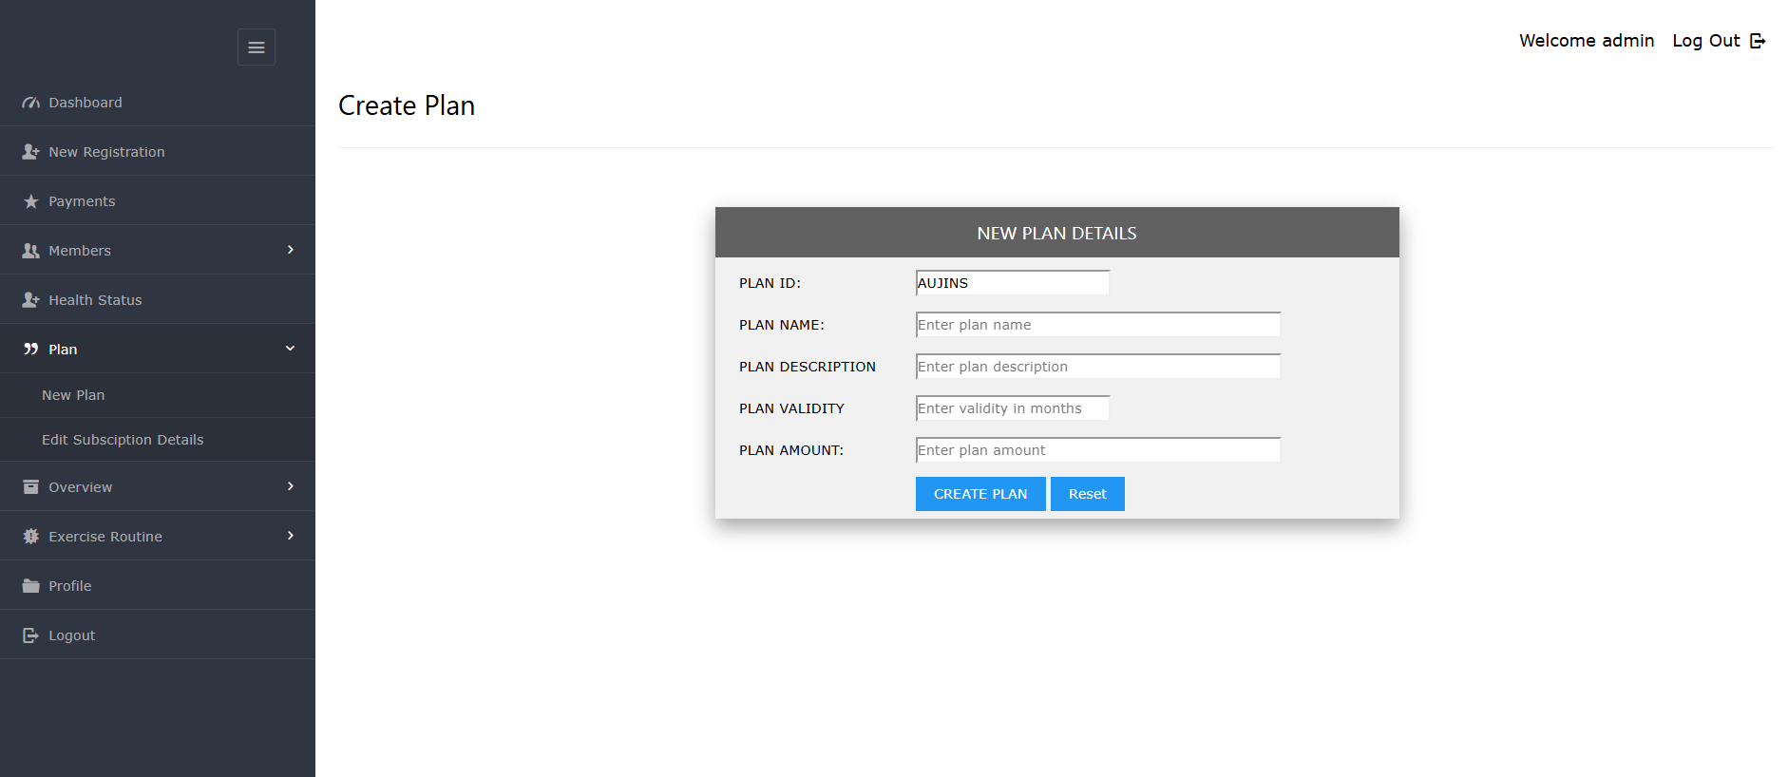

The image displays a "Create a New Plan" section for clients. The admin is responsible for setting up new membership plans. It allows defining plan details such as duration and pricing. The admin can customize plans based on client needs. This feature helps in offering flexible membership options. Once created, the plan becomes available for selection. The setup ensures smooth plan management for the gym.

Manage Plan Page :

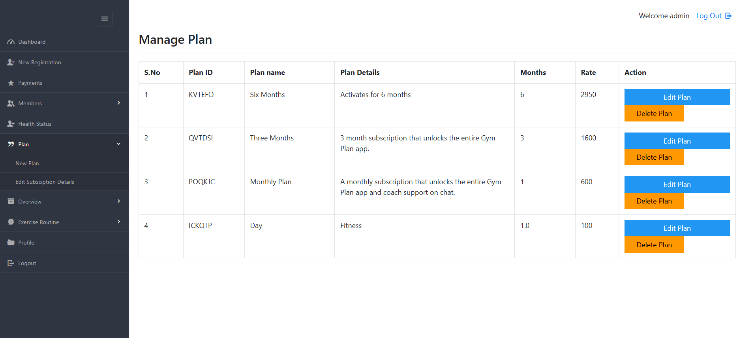

The image displays a "Current Plan" section for clients. It shows the membership plans currently in use. The details include plan duration, features, and pricing. Clients can review their active plans easily. This helps in tracking their membership status. The system ensures smooth management of ongoing plans. It provides a clear overview of active subscriptions.

Overview :
Member Per Month page :

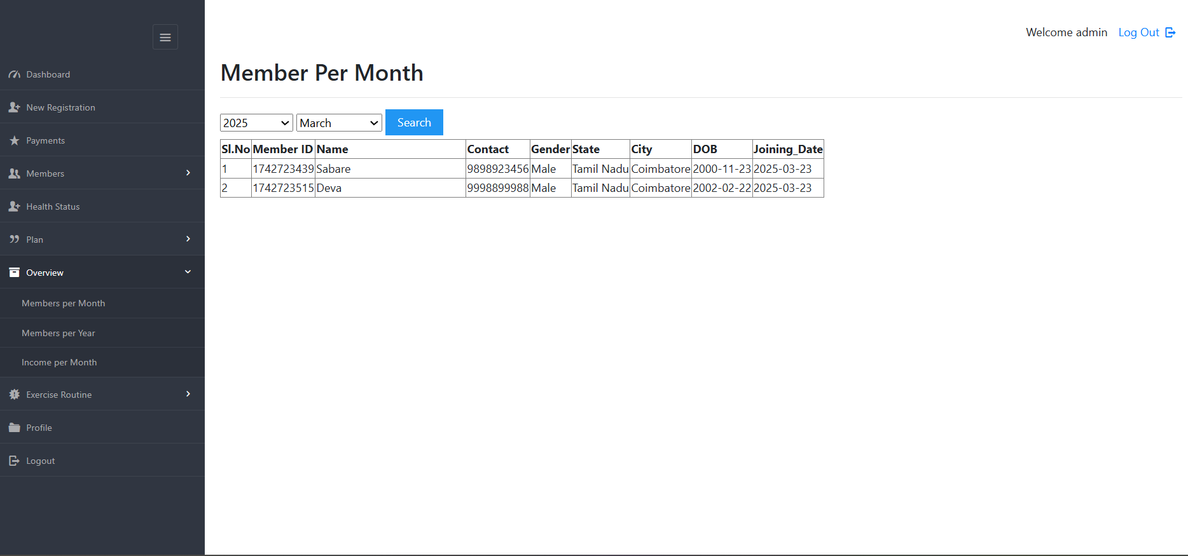

The image displays the "Members Per Month" section. It shows the number of members joining each month. This helps in tracking membership growth over time. The data provides insights into trends and patterns. It allows for better planning and management. Monitoring monthly memberships helps in improving gym strategies. The setup ensures effective membership tracking and analysis.

Member Per Year Page :

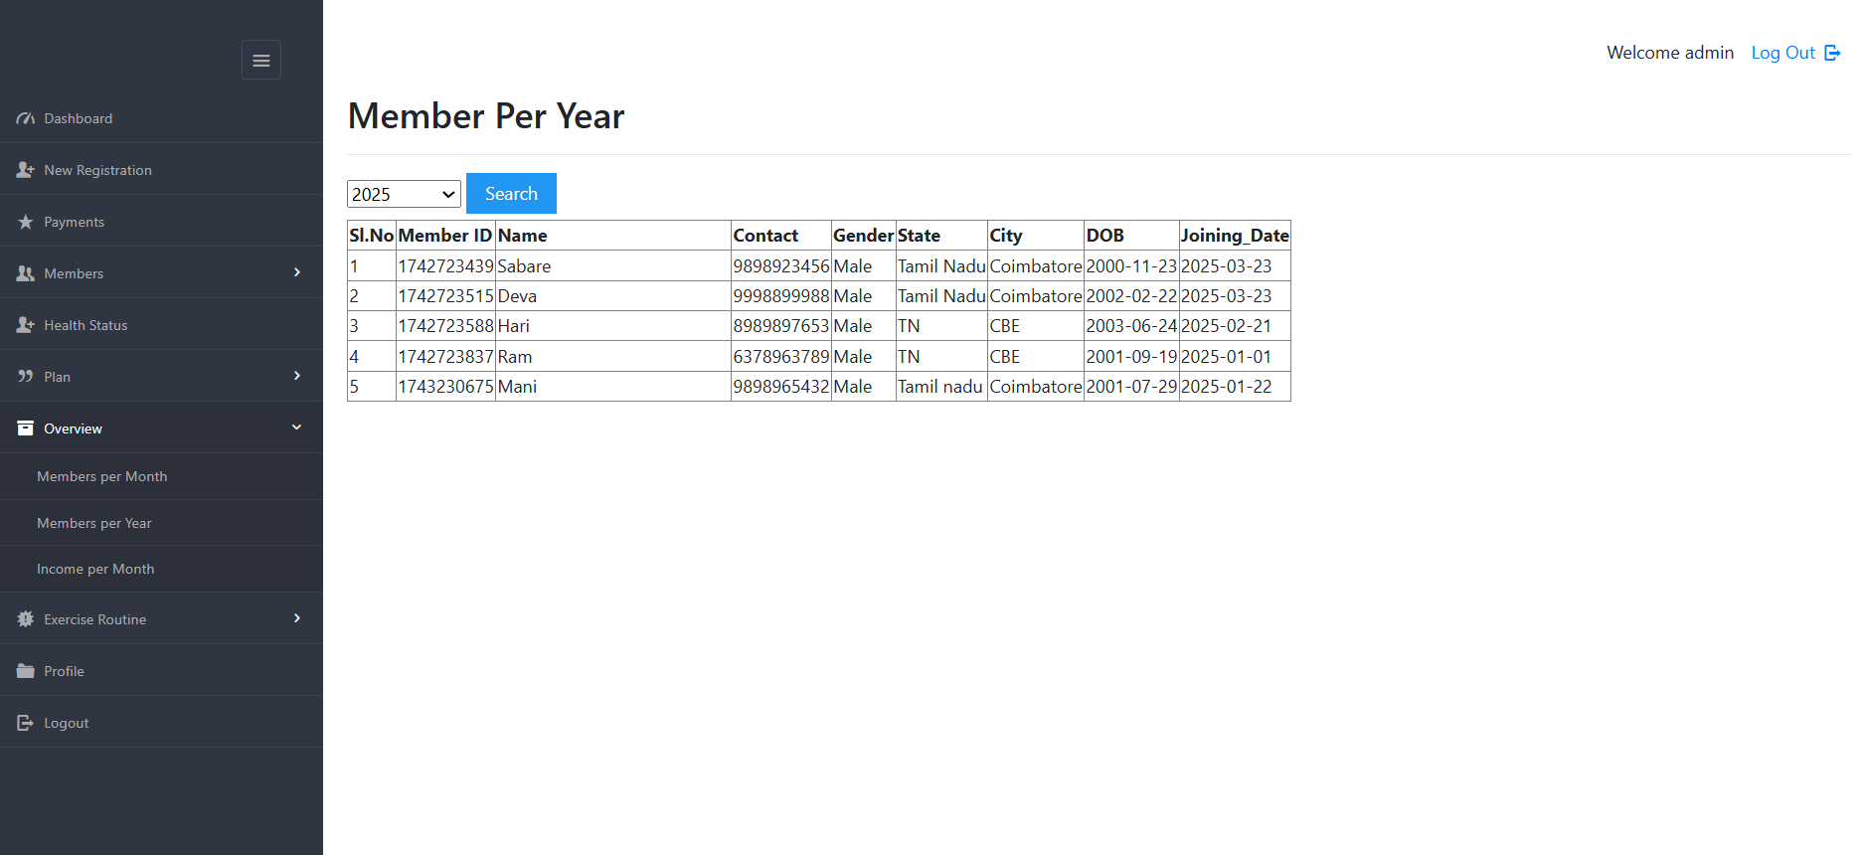

The image displays the "Members Per Year" section. It shows the total number of members joining each year. This helps in analyzing long-term membership growth. The data provides insights into yearly trends and patterns. It allows for better strategic planning and management. Tracking yearly memberships helps in evaluating gym performance. The setup ensures efficient monitoring of membership progress over time.

Income Per Month Page :

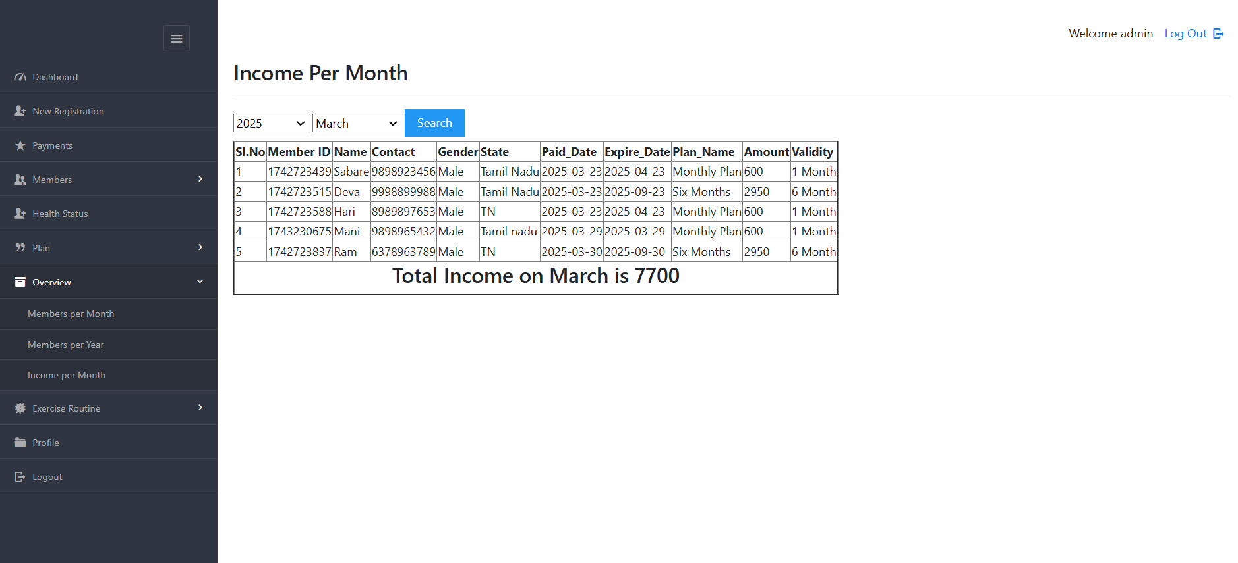

The image displays the "Income Per Year" section. It shows the total revenue generated annually. This helps in analyzing the gym's financial growth. The data provides insights into yearly income trends. It allows for better financial planning and decision-making. Tracking yearly income helps in evaluating business performance. The setup ensures efficient monitoring of financial progress over time.

Exercise Routine :
Create Routine Page :

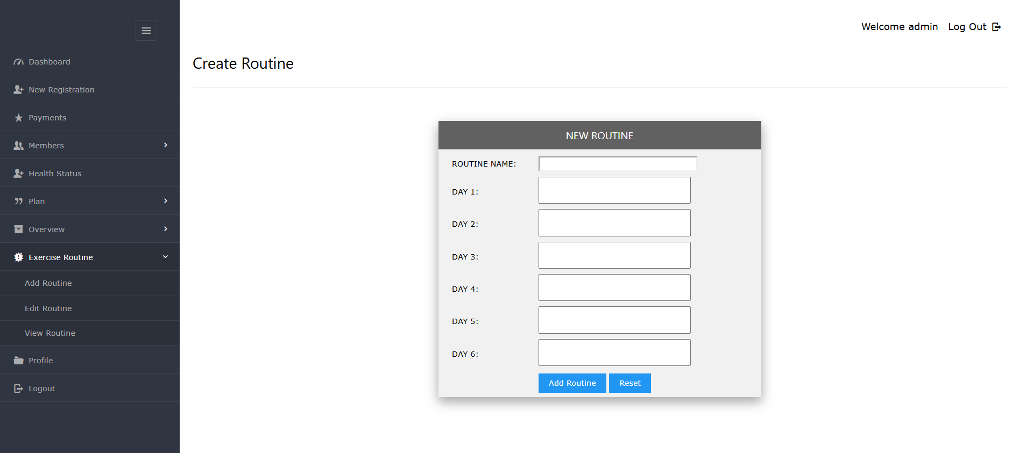

The image displays the "Create Routine" section. It allows for designing customized workout routines. Trainers can set exercises, durations, and schedules. This helps in creating structured fitness plans for clients. The routine ensures effective and goal-oriented training. It helps members stay consistent with their workouts. The setup supports better fitness management and progress tracking.

Edit Routines Page :

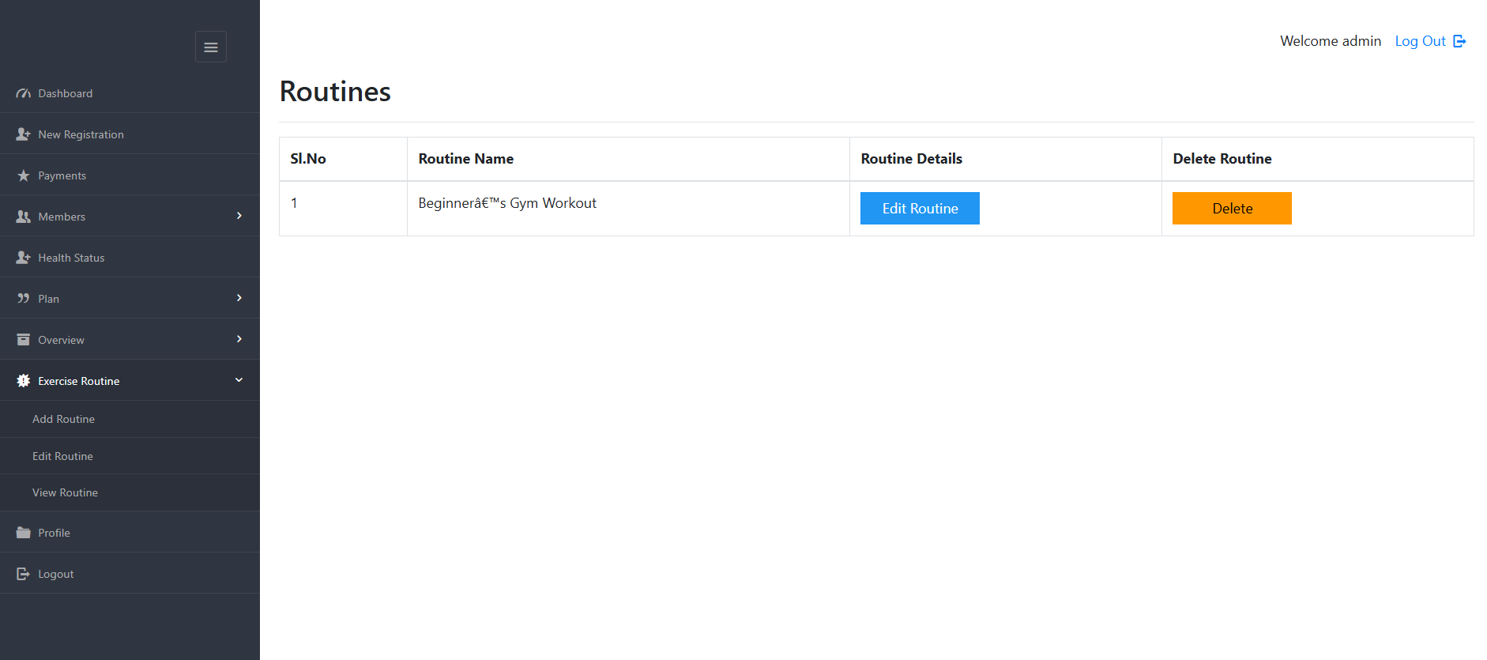

The image displays the "Edit Routine for Client" section managed by the admin. It allows the admin to modify a client’s workout plan. Changes can be made to exercises, durations, and schedules. This helps in customizing routines based on client needs. Adjustments ensure the plan aligns with fitness goals. It supports effective training and progress tracking. The setup allows for smooth and flexible workout management.

View Routines Page :

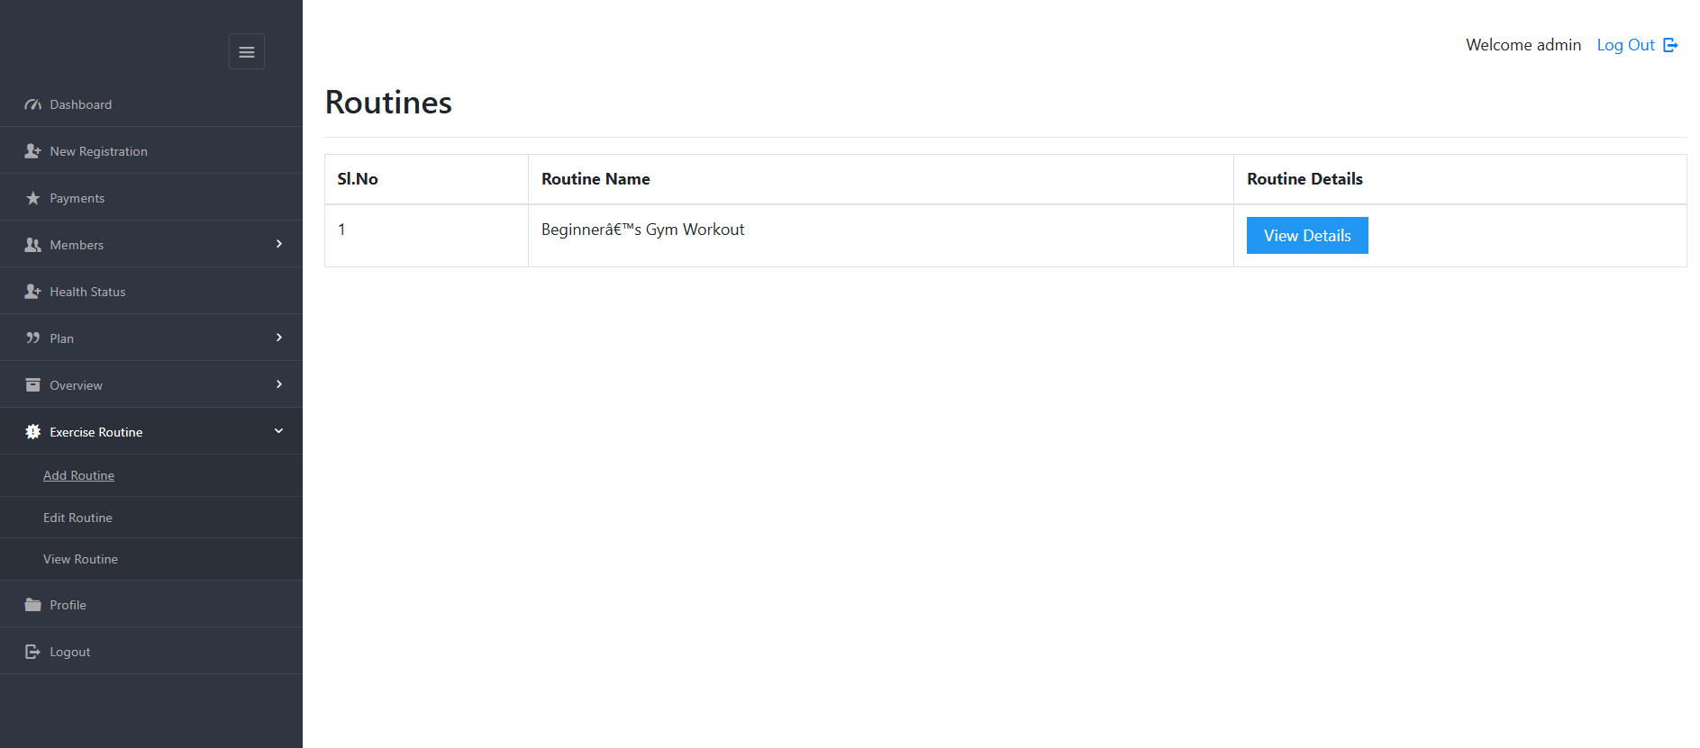

The image displays the "View Routine for Client" section managed by the admin. It shows the assigned workout plan for a client. The routine includes exercises, durations, and schedules. This helps the admin monitor the client’s fitness progress. It ensures the workout plan is being followed properly. The admin can review details and make necessary adjustments. The setup allows for effective fitness tracking and management.

Profile Page :

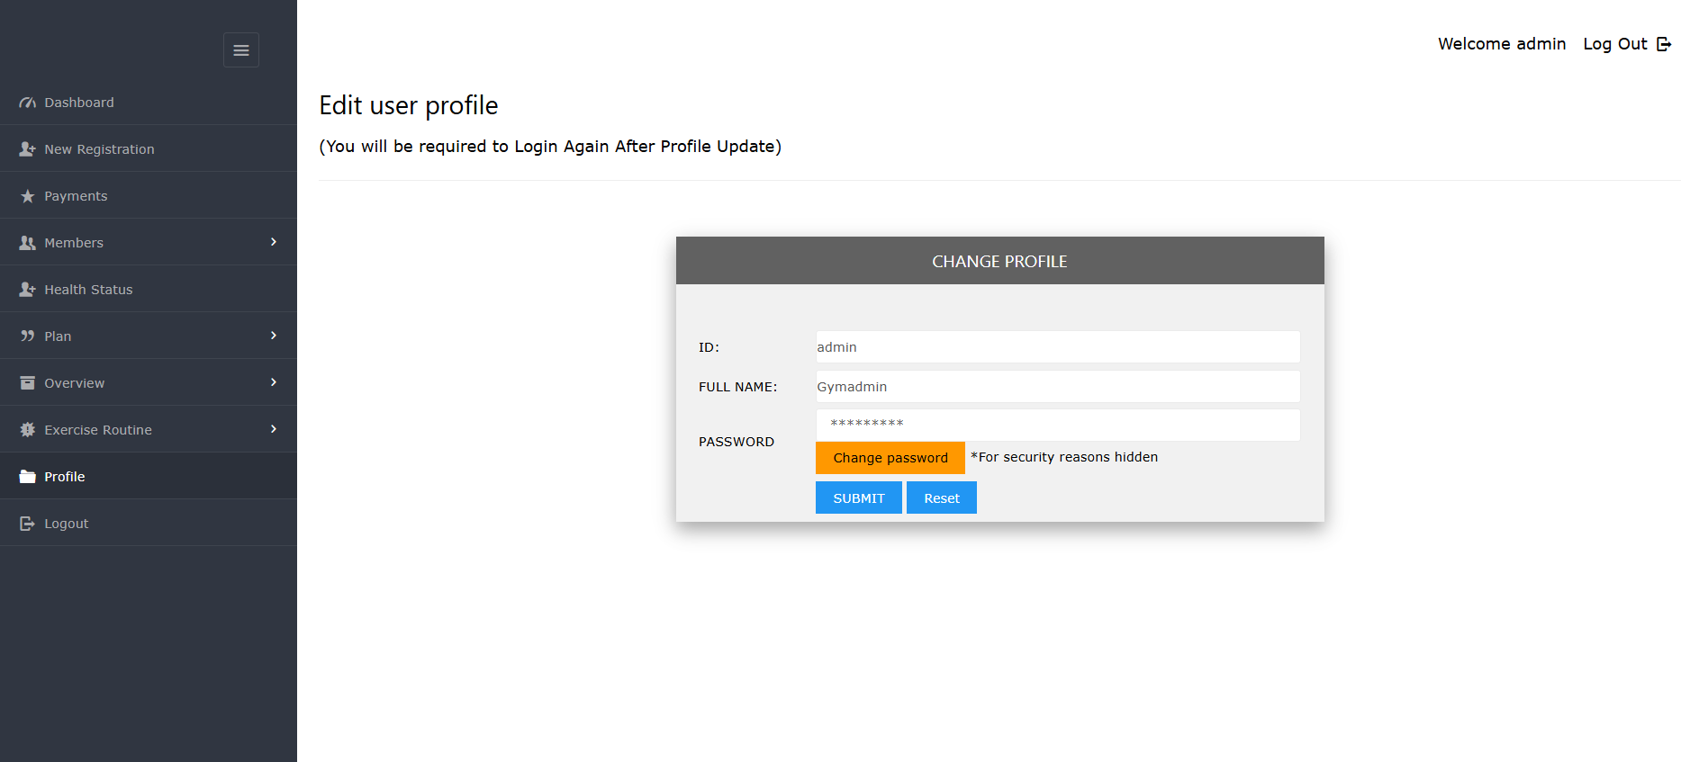

The image displays the admin's profile page. It contains personal details and account information. The profile may include the admin’s name, email, and role. This section helps in managing admin credentials. It allows for updates and modifications if needed. The profile page ensures secure access to admin settings. The setup supports efficient account management and organization.

CONCLUSION AND FUTURE ENHANCEMENT

6. CONCLUSION AND FUTURE ENHANCEMENT

6.1 Conclusion
In conclusion, this system effectively streamlines gym management by providing features such as member registration, payment tracking, health status monitoring, and routine management. The platform enhances efficiency by offering a user-friendly dashboard for tracking total income, active members, and available plans. With functionalities like editing and viewing member details, monitoring expired and active packages, and customizing workout routines, the system ensures seamless administration. By integrating these features, the gym can enhance customer experience, improve operational management, and maintain accurate records. Overall, this system simplifies gym operations and contributes to better fitness management.

6.2 Scope for Further Enhancement
While the current system provides comprehensive gym management functionalities, there is scope for further improvement. Future enhancements may include integrating automated notifications for membership renewal reminders, advanced analytics for tracking member progress, and AI-based workout recommendations. Additionally, incorporating mobile app support can provide members with easier access to their plans and health status. Secure online payment gateways and multi-user role management can further enhance usability and security. By implementing these improvements, the system can offer a more advanced and efficient gym management experience.

BIBLIOGRAPHY
- Books
  - Ullman, L. (2022). PHP and MySQL for Dynamic Web Sites: Visual QuickPro Guide (5th Edition). Peachpit Press.
  - Nixon, R. (2021). Learning PHP, MySQL & JavaScript: With jQuery, CSS & HTML5 (5th Edition). O'Reilly Media.
- Research Papers & Journals
  - Smith, J., & Brown, K. (2020). "Enhancing Web-Based Applications with PHP and MySQL." International Journal of Computer Science and Applications, 15(4), 89-102.
  - Patel, R., & Sharma, L. (2022). "Security Best Practices in PHP and MySQL-Based Web Applications." Journal of Web Development and Security, 10(2), 56-70.
- Web Resources
  - PHP.net. (2024). "PHP Manual and Documentation." Retrieved from www.php.net
  - MySQL.com. (2024). "MySQL Reference Manual." Retrieved from www.mysql.com
- Software & Technology References
  - W3Schools. (2024). "PHP & MySQL Tutorial." Retrieved from www.w3schools.com
  - Stack Overflow Community. (2023). "Common Issues and Solutions in PHP and MySQL Development." Retrieved from www.stackoverflow.com
- Theses & Dissertations
  - Williams, D. (2021). "Developing a Web-Based Gym Management System Using PHP and MySQL." Master's Thesis, University of California.
- Conference Proceedings
  - Lee, H., & Chen, P. (2023). "Optimizing Performance in PHP and MySQL Applications." Proceedings of the International Conference on Web Technologies, 45-58.

